**Environment** **Setup**

**C** **reate** **a** **Flask** **Project**

|  |  |
| --- | --- |
| Team ID | PNT2022TMID50454 |
| Project Name | Nutrition Assistant Application |

**Code** **:**

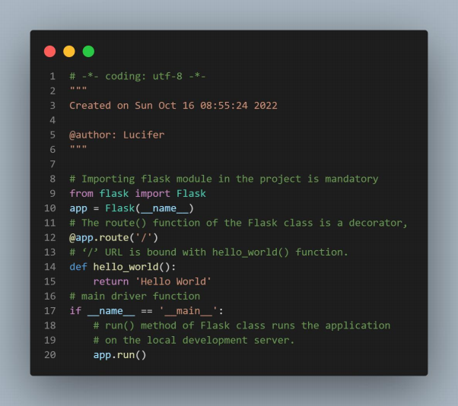

**Terminal** **:**

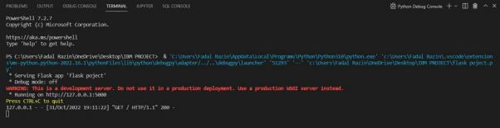

**Page** **:**

